Small Paws®
Rescue
Achievements

- The largest organized Bichon Frise rescue organization in the country today ~ 6,000 members in 26 countries and 800 volunteers Nationwide!
- Small Paws® Rescue has rescued, vetted, and rehomed over 8000 Bichons since its inception in September of 1998!
Bichon Troy receiving medical care funded
by Small Paws® Rescue
- Small Paws® Rescue has saved the lives
of 78 Bichons with heart murmurs. They each
had life-saving surgery to correct their heart
murmurs and today are living normal happy
lives!
- Small Paws® Rescue was featured on the
cable network Animal Planet for 5 years in their
series, “A Pet Story”. Small Paws® Rescue is
currently featured on Animal Planet’s new
series “Dogs 101”.
- Small Paws® Rescue is frequently invited
to speak at national functions to further
educate the public about the need for breed
rescue organizations to exist, the importance
of spaying and neutering your pet, and the
suffering that continues daily in the puppy
mills of America.
OUR VISION: We hope to see a
day when there is no longer a
market for puppies sold in the
pet shops of America. Then,
and only then, will the
suffering endured by
thousands of companion
animals in the puppy mills
of America cease.

A Federal Not-For-Profit
Animal Rescue Organization,
501 (C)(3)
You can donate by using our
secure online credit card site.
Or you may send a check to:
Small Paws® Rescue, Inc.
3316 S. 72nd W. Avenue
Tulsa, Oklahoma 74107
For more information,
please visit our website at
http://www.smallpawsrescue.org

The text, photos, logo, and illustrations in this document are the sole property
of Small Paws® Rescue, Inc. Copying, distributing, or otherwise using this
information by someone other than an authorized agent of
Small Paws® Rescue, Inc. is strictly prohibited. © September 2008

The largest Bichon Frise
rescue effort in the country!

Miss Lily, SPR Rescue and former “breeder” Bichon

The mission of Small Paws® Rescue Inc., a
charitable, federal not-for-profit organization, is
to rescue and supply Bichons Frise or
Bichon mixes, nationwide, regardless of age or
medical condition, with love, shelter, food,
human companionship, medical care, and spay-
neuter services through local veterinarians until
permanent placement is secured into a
prescreened loving home, as our resources allow.

Small Paws® Rescue, Inc. is a Federal Not-For-Profit
Animal Rescue Organization, 501(C) (3).

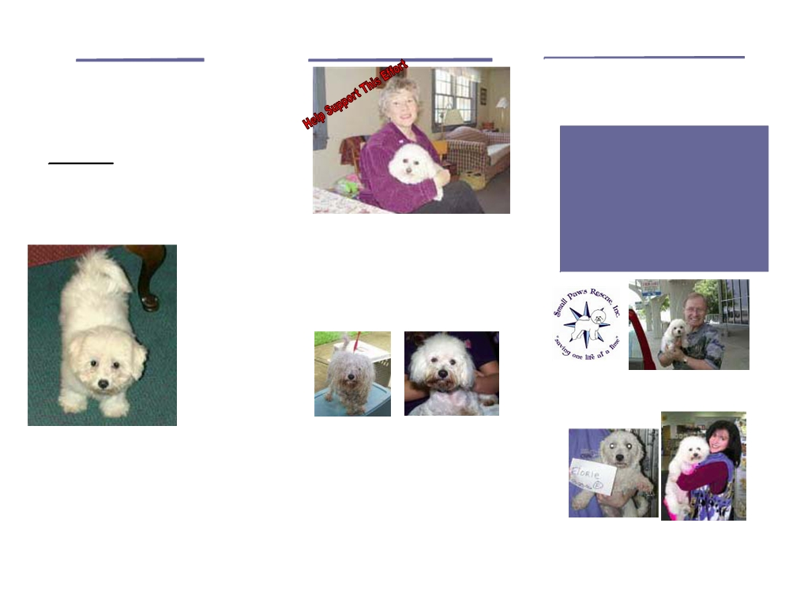

What We Do
We feel that Small Paws® Rescue is 30% about the dogs and 70% about the way that the dogs affect the people. We
feel that when we place a rescue
Bichon we touch a PERSON in a way
that they will never, ever be the same.
OUR VISION: We hope to see a day
when there is no longer a market for
puppies sold in the pet shops of
America. Then, and only then, will the
suffering endured by thousands of
companion animals in the puppy mills
of America cease.
Marcie, a fluffy,
white Bichon
Frise born in a
Missouri puppy
mill, was born
with a heart
murmur. Her
chances for a
happy life were
slim until she
was saved by
Small Paws®
Rescue, a
group
dedicated to
saving any
unwanted or
unloved Bichon
Frise.

Our goal is to ensure that no Bichon Frise is forced to live his or her life in a
puppy mill or needlessly euthanized
anywhere in America because of the
lack of medical care or an available,
loving home.
Our volunteers are willing to foster,
transport, or otherwise assist in this
massive rescue effort.
What You Can Do

Pamela worked with Small Paws Rescue to give a
better life to Lucy, a 6-year old Bichon Frise whose
life was spent in a cage in a “puppy mill,” where
her sole purpose was breeding
Would you like to help support this effort? Small Paws®Rescue Inc. is a
501 (C)(3) tax-exempt, charitable
ORGANIZATION! All donations are
TAX DEDUCTIBLE!

Gillie" was rescued from a South Texas kill shelter
thanks to Small Paws® support!
Small Paws® Rescue Inc. operates solely on donations from others who share a passion
for saving the lives of the unwanted and
unloved. If you would like to help support this
effort, you may send a donation directly to:
Small Paws® Rescue, Inc.
c/o Robin Pressnall, Executive Director
3316 S. 72nd.W. Avenue
Tulsa, Oklahoma 74107

For More Information
Visit our website at:
www.smallpawsrescue.org

* Media Inquiries Call 1-918-638-5854.
Online Services:
Online Adoption Applications
Online Foster Home Applications
Online Gift Shoppe
Meet the Staff and Board of Trustees
Secure, Online Donation Payment
Join the Mailing List
Media Stories from Across the Country
Bi-Annual Auction Fundraisers
eBay Store
iGIVE.comMarketplace

Cheri, heart murmur survivor
going to her new home!

Florie now named Charlotte, before, and with
her new Mama after adoption! Charlotte was
rescued from a puppy mill auction

